**Soal untuk calon DBA**

Sebuah toko bunga mempunyai data stock dan penjualan sebagai berikut :

Table bunga

|  |  |  |
| --- | --- | --- |
| id | nama | keterangan |
| 1 | melati | Bunga putih kecil harum |
| 2 | mawar | Bunga dengan batang berduri |
| 3 | tulip | Bunga warnawarni dari belanda |
| 4 | angrek | - |

Table satuan

|  |  |  |
| --- | --- | --- |
| id | nama | desc |
| 1 | kg | Perhitungan berdasarkan berat |
| 2 | batang | Perhitungan berdasarkan batang yang mempunyai bunga |
| 3 | pot | Perhitungan berdasarkan 1 wadah |

Table harga

|  |  |  |  |  |
| --- | --- | --- | --- | --- |
| id | id_bunga | id_satuan | harga_beli | harga_jual |
| 1 | 1 | 1 | 25000.00 | 30000.00 |
| 2 | 2 | 1 | 100000.00 | 150000.00 |
| 3 | 2 | 2 | 10000.00 | 15000.00 |
| 4 | 3 | 2 | 300000.00 | 350000.00 |
| 5 | 4 | 3 | 250000.00 | 300000.00 |

Table stock

|  |  |  |  |
| --- | --- | --- | --- |
| id | id_bunga | id_satuan | stock |
| 1 | 4 | 3 | 10 |
| 2 | 2 | 1 | 5 |
| 3 | 3 | 2 | 20 |
| 4 | 2 | 2 | 50 |
| 5 | 1 | 1 | 50 |

Table keranjang

|  |  |  |  |  |  |
| --- | --- | --- | --- | --- | --- |
| id | trx_id | id_bunga | id_satuan | jumlah | amount |
| 1 | 1 | 2 | 2 | 10 | 150000.00 |
| 2 | 2 | 1 | 1 | 2 | 60000.00 |
| 3 | 2 | 2 | 2 | 5 | 75000.00 |
| 4 | 3 | 4 | 3 | 2 | 600000.00 |
| 5 | 4 | 2 | 1 | 1 | 150000.00 |
| 6 | 4 | 4 | 3 | 1 | 300000.00 |
| 7 | 5 | 1 | 1 | 5 | 150000.00 |

Table transaction

|  |  |  |  |
| --- | --- | --- | --- |
| id | tanggal_order | status | total_amount |
| 1 | 2018-09-29 10:31:01 | sukses | 150000.00 |
| 2 | 2018-29-29 15:28:05 | sukses | 135000.00 |
| 3 | 2018-30-30 07:15:25 | proses | 600000.00 |
| 4 | 2018-09-30 12:30:45 | sukses | 450000.00 |
| 5 | 2018-09-30 14:23:23 | sukses | 150000.00 |

Dari data di atas mohon dibuatkan seperti point-point dibawah :

1. Gambarkan schema diagram DB (relasi-relasi dari tiap table).

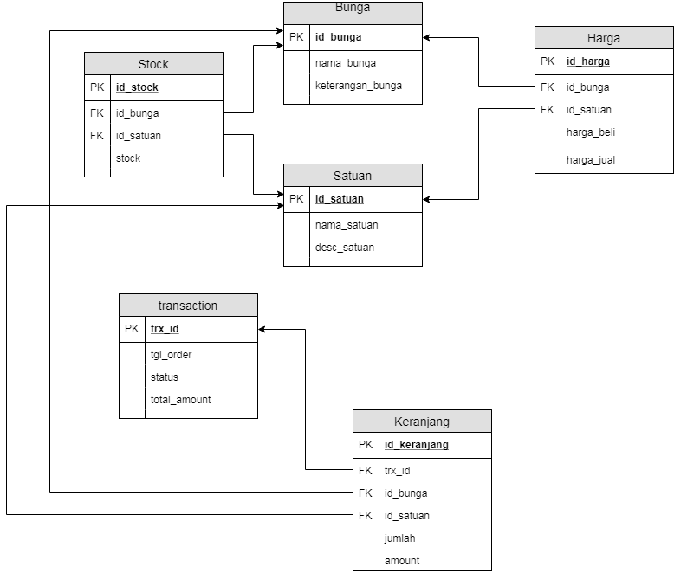

1. Buatkan query untuk membuat database diatas

CREATE DATABASE tokobunga;

CREATE TABLE bunga (

id_bunga varchar2(10),

nama_bunga varchar2(20),

keterangan_bunga varchar2(50),

CONSTRAINT pk_bunga PRIMARY KEY(id_bunga)

);

CREATE TABLE satuan(

id_satuan varchar2(10),

nama_satuan varchar2(20),

desc_satuan varchar2(50)

);

CREATE TABLE harga(

id_harga varchar2(10),

id_bunga varchar2(10),

id_satuan varcar2(10),

harga_beli number(10),

harga_jual number(10),

CONSTRAINT pk_harga PRIMARY KEY (id_harga),

CONSTRAINT fk_harga FOREIGN KEY (id_bunga) REFERENCES bunga ON DELETE CASCADE,

CONSTRAINT fk_harga1 FOREIGN KEY (id_satuan) REFERENCES satuan ON DELETE CASCADE

);

CREATE TABLE stock(

id_stock varchar2(10),

id_bunga varchar2(10),

id_satuan varchar2(10),

stock number(4),

CONSTRAINT pk_stock PRIMARY KEY (id_stock),

CONSTRAINT fk_stock FOREIGN KEY (id_bunga) REFERENCES bunga ON DELETE CASCADE,

CONSTRAINT fk_stock1 FOREIGN KEY (id_satuan) REFERENCES satuan ON DELETE CASCADE

):

CREATE TABLE transaction(

trx_id varchar2(10),

tanggal_order date,

status varchar2(10),

total_amount number(10),

CONSTRAINT pk_transaction PRIMARY KEY (trx_id)

);

CREATE TABLE keranjang(

id_keranjang varchar2(10),

trx_id varchar2(10),

id_bunga varchar2(10),

id_satuan varchar2(10),

jumlah number(4),

amount number(10),

CONSTRAINT pk_keranjang PRIMARY KEY (id_keranjang),

CONSTRAINT fk_ keranjang FOREIGN KEY (trx_id) REFERENCES transaction ON DELETE CASCADE,

CONSTRAINT fk_ keranjang1 FOREIGN KEY (id_bunga) REFERENCES bunga ON DELETE CASCADE,

CONSTRAINT fk_ keranjang2 FOREIGN KEY (id_satuan) REFERENCES satuan ON DELETE CASCADE

);

INSERT INTO bunga (id_bunga,nama_bunga,keterangan_bunga) values (‘1’, ‘melati’, ‘Bunga putih kecil harum’);

INSERT INTO bunga (id_bunga,nama_bunga,keterangan_bunga) values (‘2’, ‘mawar, ‘Bunga dengan batang berduri);

INSERT INTO bunga (id_bunga,nama_bunga,keterangan_bunga) values (‘3’, ‘melati’, ‘Bunga putih kecil harum’);

INSERT INTO bunga (id_bunga,nama_bunga,keterangan_bunga) values (‘4’, ‘anggrek’, null);

INSERT INTO satuan (id_satuan,nama_satuan,desc_satuan) values (‘1’, ‘kg’, ‘Perhitungan berdasarkan berat’);

INSERT INTO satuan (id_satuan,nama_satuan,desc_satuan) values (‘2’, ‘batang’, ‘Perhitungan berdasarkan batang yang mempunyai bunga’);

INSERT INTO satuan (id_satuan,nama_satuan,desc_satuan) values (‘3’, ‘pot, ‘Perhitungan berdasarkan 1 wadah’);

INSERT INTO harga (id_harga,id_bunga,id_satuan,harga_beli,harga_jual) values (‘1’,’1’,’1’,25000,30000);

INSERT INTO harga (id_harga,id_bunga,id_satuan,harga_beli,harga_jual) values (‘2’,’2’,’1’,100000,150000);

INSERT INTO harga (id_harga,id_bunga,id_satuan,harga_beli,harga_jual) values (‘3’,’2’,’2’,10000,15000);

INSERT INTO harga (id_harga,id_bunga,id_satuan,harga_beli,harga_jual) values (‘4’,’3’,’2’,300000,350000);

INSERT INTO harga (id_harga,id_bunga,id_satuan,harga_beli,harga_jual) values (‘5’,’4’,’3’,25000,300000);

INSERT INTO stock (id_stock,id_bunga,id_satuan,stock) values (‘1’,’4’,’3’,10);

INSERT INTO stock (id_stock,id_bunga,id_satuan,stock) values (‘2’,’2’,’1’,5);

INSERT INTO stock (id_stock,id_bunga,id_satuan,stock) values (‘3’,’3’,’2’,20);

INSERT INTO stock (id_stock,id_bunga,id_satuan,stock) values (‘4’,’2’,’2’,50);

INSERT INTO stock (id_stock,id_bunga,id_satuan,stock) values (‘5’,’1’,’1’,50);

INSERT INTO transaction (trx_id,tanggal_order,status,total_amount) values (‘1’, ’20180929 10:31:01 AM’, ’sukses’, 150000);

INSERT INTO transaction (trx_id,tanggal_order,status,total_amount) values (‘2’, ’20182929 15:28:05 PM’, ’sukses’, 135000);

INSERT INTO transaction (trx_id,tanggal_order,status,total_amount) values (‘3’, ’20183030 07:15:25 AM’, ‘proses’, 600000);

INSERT INTO transaction (trx_id,tanggal_order,status,total_amount) values (‘4’, ’20180930 12:30:45 PM’, ’sukses’, 450000);

INSERT INTO transaction (trx_id,tanggal_order,status,total_amount) values (‘5’, ’20180930 14:23:23 PM’, ’sukses’, 150000);

INSERT INTO keranjang (id_keranjang,trx_id,id_bunga,id_satuan,jumlah,amount) values (‘1,’1’,’2’,’2’,10,150000);

INSERT INTO keranjang (id_keranjang,trx_id,id_bunga,id_satuan,jumlah,amount) values (‘2,’2’,’1’,’1’,2,60000);

INSERT INTO keranjang (id_keranjang,trx_id,id_bunga,id_satuan,jumlah,amount) values (‘3,’2’,’2’,’2’,5,75000);

INSERT INTO keranjang (id_keranjang,trx_id,id_bunga,id_satuan,jumlah,amount) values (‘4,’3’,’4’,’3’,2,600000);

INSERT INTO keranjang (id_keranjang,trx_id,id_bunga,id_satuan,jumlah,amount) values (‘5,’4’,’2’,’1’,1,150000);

INSERT INTO keranjang (id_keranjang,trx_id,id_bunga,id_satuan,jumlah,amount) values (‘6,’4’,’4’,’1’,1,300000);

INSERT INTO keranjang (id_keranjang,trx_id,id_bunga,id_satuan,jumlah,amount) values (‘7,’5’,’1’,’5’,5,150000);

1. Pricelist

|  |  |  |  |  |  |
| --- | --- | --- | --- | --- | --- |
| Id_pricelist | Nama_bunga | satuan | Stock_bunga | Harga_beli | Harga_jual |
| 1 | Melati | Kg | 50 | 25000 | 30000 |
| 2 | Mawar | Kg | 5 | 100000 | 150000 |
| 3 | Mawar | Batang | 50 | 10000 | 15000 |
| 4 | Tulip | Batang | 20 | 300000 | 350000 |
| 5 | Angrek | Pot | 10 | 250000 | 300000 |

1. Query

Select nama_bunga as item, status, jumlah, amount as total amount from bunga, keranjang, transaksi where status=’sukses’ (select sysdate from dual);

1. Query

Select nama_bunga as item from bunga, transaction, keranjang where sysdate not in (select sysdate from dual);